

**2 Courses**

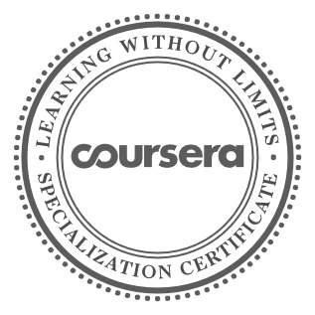

Neural Networks and Deep Learning

Improving Deep Neural Networks: Hyperparameter tuning, Regularization and Optimization

02/03/2025

Rahul B C



has successfully completed the online, non-credit Specialization

Deep Learning

The Deep Learning Specialization is designed to prepare learners to participate in the development of cutting-edge AI technology, and to understand the capability, the challenges, and the consequences of the rise of deep learning. Through the interconnected courses, learners develop a profound knowledge of the hottest AI algorithms, mastering deep learning from its foundations (neural networks) to its industry applications.

The online specialization named in this certificate may draw on material from courses taught on-campus, but the included courses are not equivalent to on-campus courses. Participation in this online specialization does not constitute enrollment at this university. This certificate does not confer a University grade, course credit or degree, and it does not verify the identity of the learner.

Adjunct Professor Andrew Ng Computer Science

Verify this certificate at: coursera.org/verify/specialization/M5UP9G8AD8B8